Decentralised Trials Research Governance

Review Checklist

This checklist is designed to promote consistency in governance review processes for research studies submitted as a Teletrial across various health sites. This should be used as a guide for submission requirements for research governance review of clinical trials being conducted under the Teletrial model. This checklist indicates tasks relevant to either the Primary Site (PS) and/or Satellite Site (SS).
This tool is intended as an internal tool for Research Governance Officers (RGOs), outlining the additional steps required for Teletrial studies. This checklist is to be used in conjunction with standard governance review checklists, for example:
- Governance Checklist for Research Governance Officers
- Governance Submission Checklist for Researchers
To maintain the integrity of a common tool, local modifications to the form are discouraged. However, the checklist should be reviewed at least annually to ensure it remains current and aligned with evolving practices.
This resource was developed by the Governance Working Group, led by Sydney Health Partners, with significant contributions from Mid-North Coast Local Health District, whose original guidance informed its development.

SUBMISSION REQUIREMENTS | PS | SS
Approval Support Letters
Health Research Ethics Committee (HREC) approval letter for Teletrial model with PS and SS listed (approved)  If SS was added later, include evidence of HREC amendment approval | ☐ Yes  ☐ No | ☐ Yes  ☐ No
Ensure that the SSA for the PS has been authorised before approving the SSA for the SS | ☐ Yes  ☐ No | ☐ Yes  ☐ No
Head of Department (HoD) support has been provided to conduct trial as a Teletrial within LHD/health organisation (required as part of normal practice for both sites) | ☐ Yes  ☐ No | ☐ Yes  ☐ No
Clinical Trial Research Agreement (CTRA)
Clinical Trials Research Agreement (CTRA)  Head CTRA between the sponsor and PS. Negotiations should consider budgeting and equipment for all sites in the Teletrial model and can be informed by the Teletrial Supervision Plan. The Head CTRA must be executed in full prior to the execution of a subcontract with PS. | ☐ Yes  ☐ No
Head Agreement CTRA is in the name of PS [insert organisation name below] | ☐ Yes  ☐ No
Click or tap here to enter text.
Include all sites at Schedule 1, i.e., name PS and SS  If the SS is being added as an amendment, confirm that the original CTRA has been amended to include the SS | ☐ Yes  ☐ No | ☐ Yes  ☐ No
Include any additional costs at Schedule 2, i.e. SS pharmacy storage fees of IP, shipping costs of IP to SS (as required)  Note: If SS has been added at a later date, this may form part of the subcontract. | ☐ Yes  ☐ No | ☐ Yes  ☐ No
Clinical Trial Research Agreement Subcontract  This agreement is between PS and SS. PS local RGO to review prior to submitting SSA for SS | ☐ Yes  ☐ No | ☐ Yes  ☐ No
To be completed and agreed upon by PS and SS | ☐ Yes  ☐ No | ☐ Yes  ☐ No
Draft subcontract to be submitted to SS RGO as part of SSA submission for review. This contract may be submitted as an addendum to head CTRA.  CTRA Subcontract to be fully executed by all parties at the time of site authorisation of SS | ☐ Yes  ☐ No | ☐ Yes  ☐ No
Primary Site
(RGO to review in conjunction with standard governance review checklists)
Copy of Clinical Trial Cluster Identifier (CCID) | ☐ Yes  ☐ No
Submission of SSA via REGIS for RGO approval as per normal process | ☐ Yes  ☐ No
All HREC approved documentation to be used at site that would normally be submitted via REGIS for a routine SSA  Note: If Teletrial model is being implemented after initial approval, additional Master Teletrial PICF may need to be submitted for review if Teletrial information is not already included in Master PICF – particularly if SS will be consenting/recruiting participants and not through the PS. | ☐ Yes  ☐ No
Medicines Australia Form of Indemnity for clinical trials – Standard  Indemnity to be provided for each site (PS & SS) as per normal process. Draft to be submitted with SSA submission.  Indemnity can be provided separately, or within the CTRA or as an associated document – see Schedule 3. | ☐ Yes  ☐ No
Satellite Site
(RGO to review in conjunction with standard governance review checklists)
Submission of all study documents relevant to site via REGIS for RGO review by PS |  | ☐ Yes  ☐ No
Evidence of the Sponsor agreement to run the trial as a satellite model or teletrial |  | ☐ Yes  ☐ No
Indemnity between Sponsor and SS provided. Draft submitted with SSA submission.  Indemnity can be provided separately, or can be included or attached within CTRA (Schedule 3). |  | ☐ Yes  ☐ No
Clinical Trial Research Agreement Subcontract  Draft subcontract developed between PS and SS and draft submitted with SSA submission  CTRA Subcontract to be fully executed by all parties at the time of site authorisation of SS |  | ☐ Yes  ☐ No
Additional documents to be submitted to RGO
(also to be agreed to by Sponsor):
Teletrial Supervision Plan  This must be completed collaboratively between PS and SS. As this is a site-specific document, this should be commenced as soon as practicable post ethical approval being provided and sites being identified.  Supervision plan between PS and SS - To be completed, agreed upon and signed by all relevant parties, including Pharmacy (if required).  Note: you should include your local RGO in the development of this document for their feedback/comment prior to finalising with PS and obtaining all signatures. | ☐ Yes  ☐ No | ☐ Yes  ☐ No

GLOSSARY
Abbreviation | Description
CPI | Coordinating Principal Investigator
CT | Clinical Trial
CTRA | Clinical Trials Research Agreement
DCT | Decentralised Trials is new terminology to be used for ‘Teletrials’. ‘Teletrials’ is a uniquely Australian term that refers to decentralised clinical trials where telehealth technology is used to facilitate communication between the participant, the primary and satellite trial sites for some or all activities of the trial. Often referred to as a hub-and-spoke model. Source: Draft Framework for Decentralised Clinical Trials in NSW and ACT
HoD | Head of Department
HREC | Health Research Ethics Committee
IP | Investigational Product
LHD | Local Health District
PI | Principle Investigator
PICF | Patient Information and Consent Form
PS | Primary Site
REGIS | Research Ethics Governance Information System
RGO | Research Governance Officer
SSA/STE | Site Specific Assessment “SSA/STE is part of the site governance process adopted across NSW, TAS & ACT Health, by which a potential research site considers authorisation of a project to access and/or utilise its resources. SSA/STE applications are required for each site where the research will be conducted within the Centre (e.g. LHD or Network). They can be completed and submitted before ethics approval has been made but cannot be authorised until ethics approval has been obtained.” Source REGIS reference: Quick reference Guide
SS | Satellite Site

This Checklist was developed and agreed by Sydney Health Partners and representatives from the health organisations in NSW listed below (members of the Governance Working Group).

Central Coast Local Health District
Hunter New England Local Health District
Illawarra Local Health District
Murrumbidgee Local Health District
Mid North Coast Local Health District
Nepean Blue Mountains Local Health District
Northern New South Wales Local Health District
Northern Sydney Local Health District
South Western Sydney Local Health District
St Vincent’s Hospital
Sydney Local Health District: Concord Repatriation General Hospital Research Office
Sydney Local Health District: Royal Prince Alfred (RPA) RPA
The Sydney Children’s Hospitals Network
The Westmead Institute for Medical Research
Western Sydney Local Health District
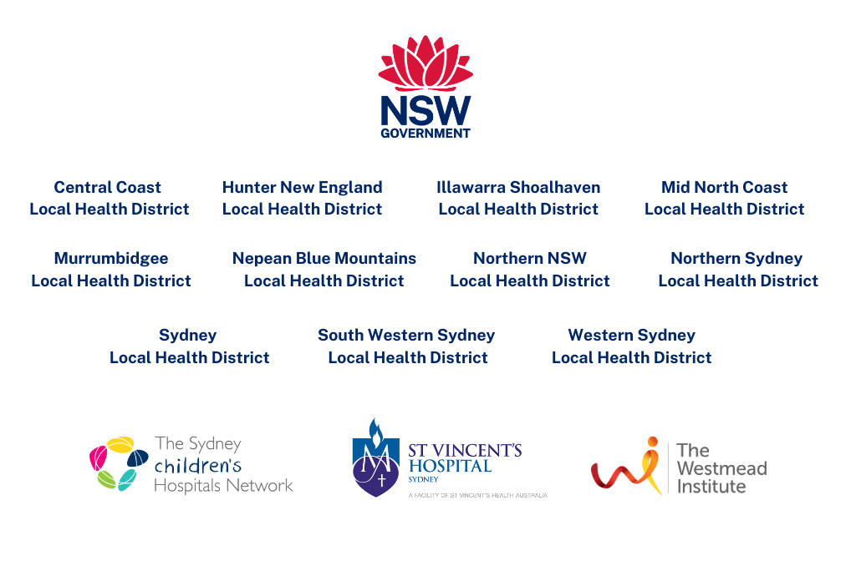

Decentralised Trials is new terminology to be used for ‘Teletrials’. ‘Teletrials’ is a uniquely Australian term that refers to decentralised clinical trials where telehealth technology is used to facilitate communication between the participant, the primary and satellite trial sites for some or all activities of the trial. Often referred to as a hub-and-spoke model. Source: Draft Framework for Decentralised Clinical Trials in NSW and ACT.
A Satellite Site is located in a geographically separate health facility, and conducts agreed delegated clinical trial activities under the supervision of the Principal Investigator at a Primary Site. (for more information, see ATP definition guide​ - Australian Teletrial Program).

